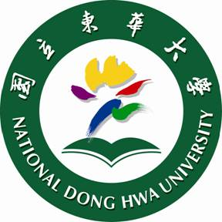
國立東華大學112學年第1學期
博士班外國學生菁英獎學金
學院審核意見表
申請人 | Laura Olivo 康蘿拉
系所 | 原住民民族學院原住民族研究國際博士班■
學號 | 81129B002
申 請 資 料 |  | 繳 交 情 形 | 備 註
1.申請表 |  | ■已繳 □未繳
2.自傳 |  | ■已繳 □未繳
3.學士班或碩士班歷年成績單 |  | ■已繳 □未繳
4.研究計畫 |  | ■已繳 □未繳
5.未來論文指導教授推薦函 |  | ■已繳 □未繳
6.學院審查意見表 |  | ■已繳 □未繳
7.畢業論文或其他有利審查資料 |  | ■已繳 □未繳 | 非必繳
學 院 審 核 意 見 (200字以上)
Laura is fascinated with indigenous cultures in Taiwan. She makes short films about Taiwanese culture based on her analysis of language use. Being a linguistics Master’s graduate, she thinks of etymology from a historical linguistics point of view, an important area to dig into when studying indigenous cultures. I therefore recommend her as the first candidate for the NDHU Scholarship for Elite Ph.D. Students Award to support her eagerness to pursue anthropology and cultural studies in our college.

As a newly established international program, we always encourage students to explore the captivating locale of Hualien, a perfect place for studying the diverse cultures of Taiwan’s indigenous peoples. With the transdisciplinary and comprehensive training, we believe our students have the potential to facilitate academic research on international indigenous peoples in the future. Not only have theoretical knowledge and empirical abilities in humanities and social
sciences research, but also able to promote equal development among diverse ethnic groups, bringing Taiwan’s indigenous peoples’ culture and wisdom to the world and leaving our legacy to the next generation.

Language is an essential part of the cultural learning process, being fluent in Portuguese, English, Mandarin and having a basic understanding of the Paiwan language, Laura is undoubtedly the best student in our College to contribute her expertise to this land and expand her influences overseas.

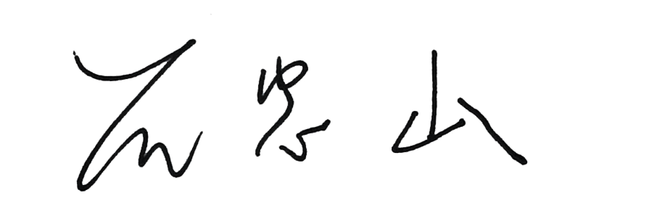
院 長 簽 章

